**ASSIGNMENT 5**

**Vulnerability Analysis of SQL Injections**

Prasani

# **INDEX**

|  |  |  |
| --- | --- | --- |
| **SL NO** | **TOPIC** | **PAGE NO** |
| 1. | Installation of Burpsuite | 2 |
| 2. | Installation of VS Code | 2 |
| 3. | Report on today’s lecture | 3 |

# **Topic: Vulnerability Analysis of SQL Injections**

ASSIGNMENT 5(DAY 5) Date:01-07-2022

1. **Screenshot of Burpsuite Installation. and summary report of what you learned today**

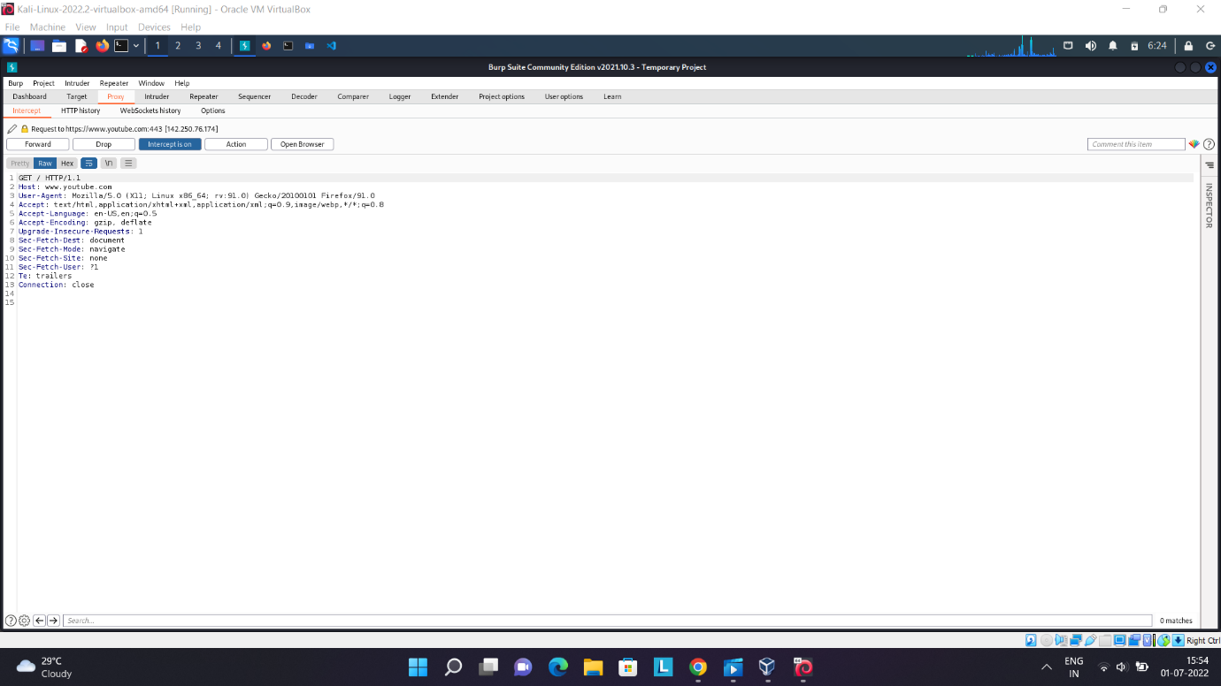

1. **Installation code of VS code with intellicode and prettier plugin.**

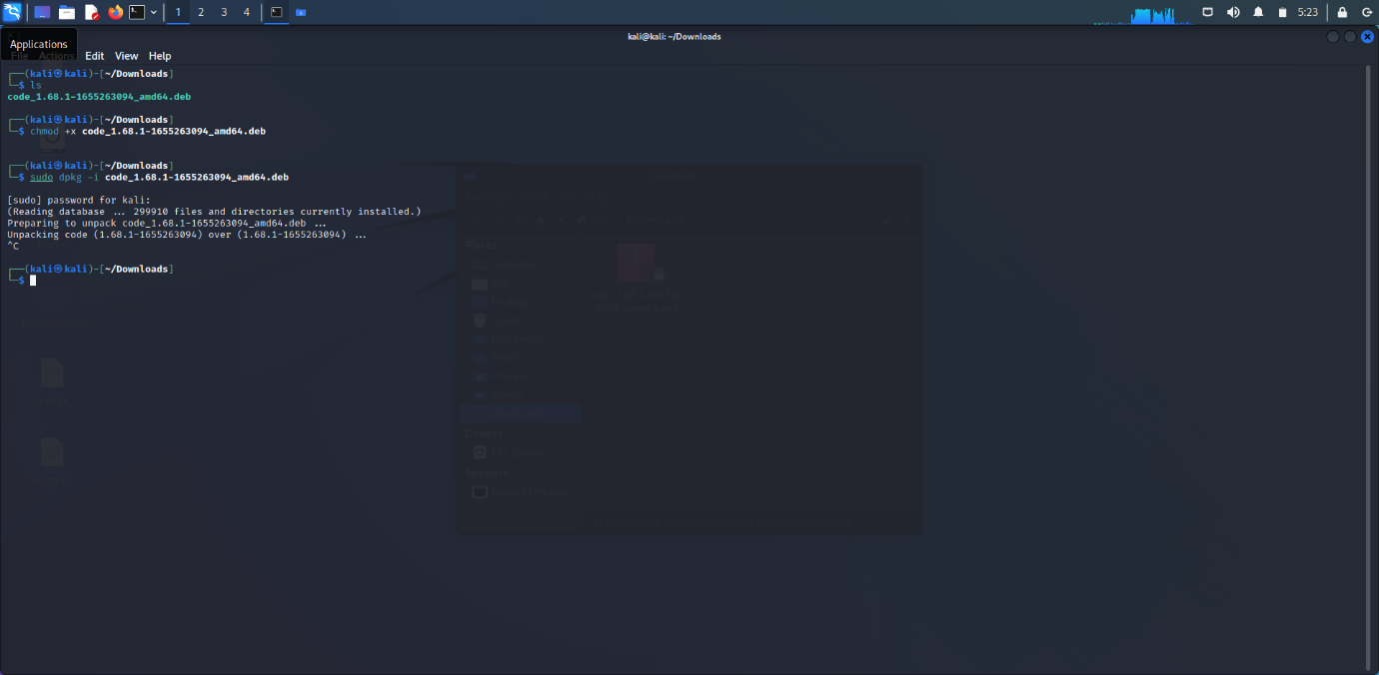

1. **Summary Report of today’s lecture.**

* We learnt about SQL Injection and types of Injection.
* Various commands in SQL Injection.
* Impact and prevention of SQL Injection.
* We learnt about Cross Site Request Forgery(CSRF).
* Types of CSRF and how does it work.
* Impact and prevention of CSRF.
* We learnt about Cross Site Scripting (XSS).
* Types of Cross Site attacks.
* We learnt about different testing tools and real attacks and preventions.

**NAME: I PRASANTI**

**SIC: 20BCEA56**

**BRANCH: CEN**